**Flume**

**Student Name: Student Id:**

**Date:**

Please use the screenshots ONLY as a reference. The written instructions have to be followed AS written.

PLEASE MAKE SURE YOU SUBMIT ALL THE SCREENSHOTS WITH TIMESTAMPS AT THE BOTTOM RIGHT (WINDOWS USERS) OR THE TOP RIGHT (MAC OSX USERS) OR ELSE YOU WILL AUTOMATICALLY QUALIFY FOR A DISCOUNT.

# Objective:

Flume is a high-performance system for data collection. It is used to ingest near real time data. The objective of this exercise is to help the students understand how to configure a flume agent and simulate live log data to ingest from a local directory into HDFS.

**NOTE:**

* **Code to be executed is highlighted in Green**
* **The explanation for all the code is provided below the code**
* **There are subtle differences in HDFS commands and common Linux commands, if you are running into an error, or not seeing what you expect double check the commands**
* **Some commands contain a (\) at the end of the first line, this signifies that the command is not complete. You may enter the code as it is shown on two lines or on one line without the “\”**
* **Maximize the terminal screen and increase the font to a visible size, otherwise points will be deducted**

Table of Contents

Objective: 1

Part-1: Setup: 3

Part-2: Configuring the Flume Agent: 6

Part-3: Running Flume: 9

Part-4: Simulating Web Log Files: 10

Part-5: Checksum: 13

ADDITIONAL NOTES: 15

Part-1: Setup: In this section we will setup the directories and permission needed to complete this exercise.

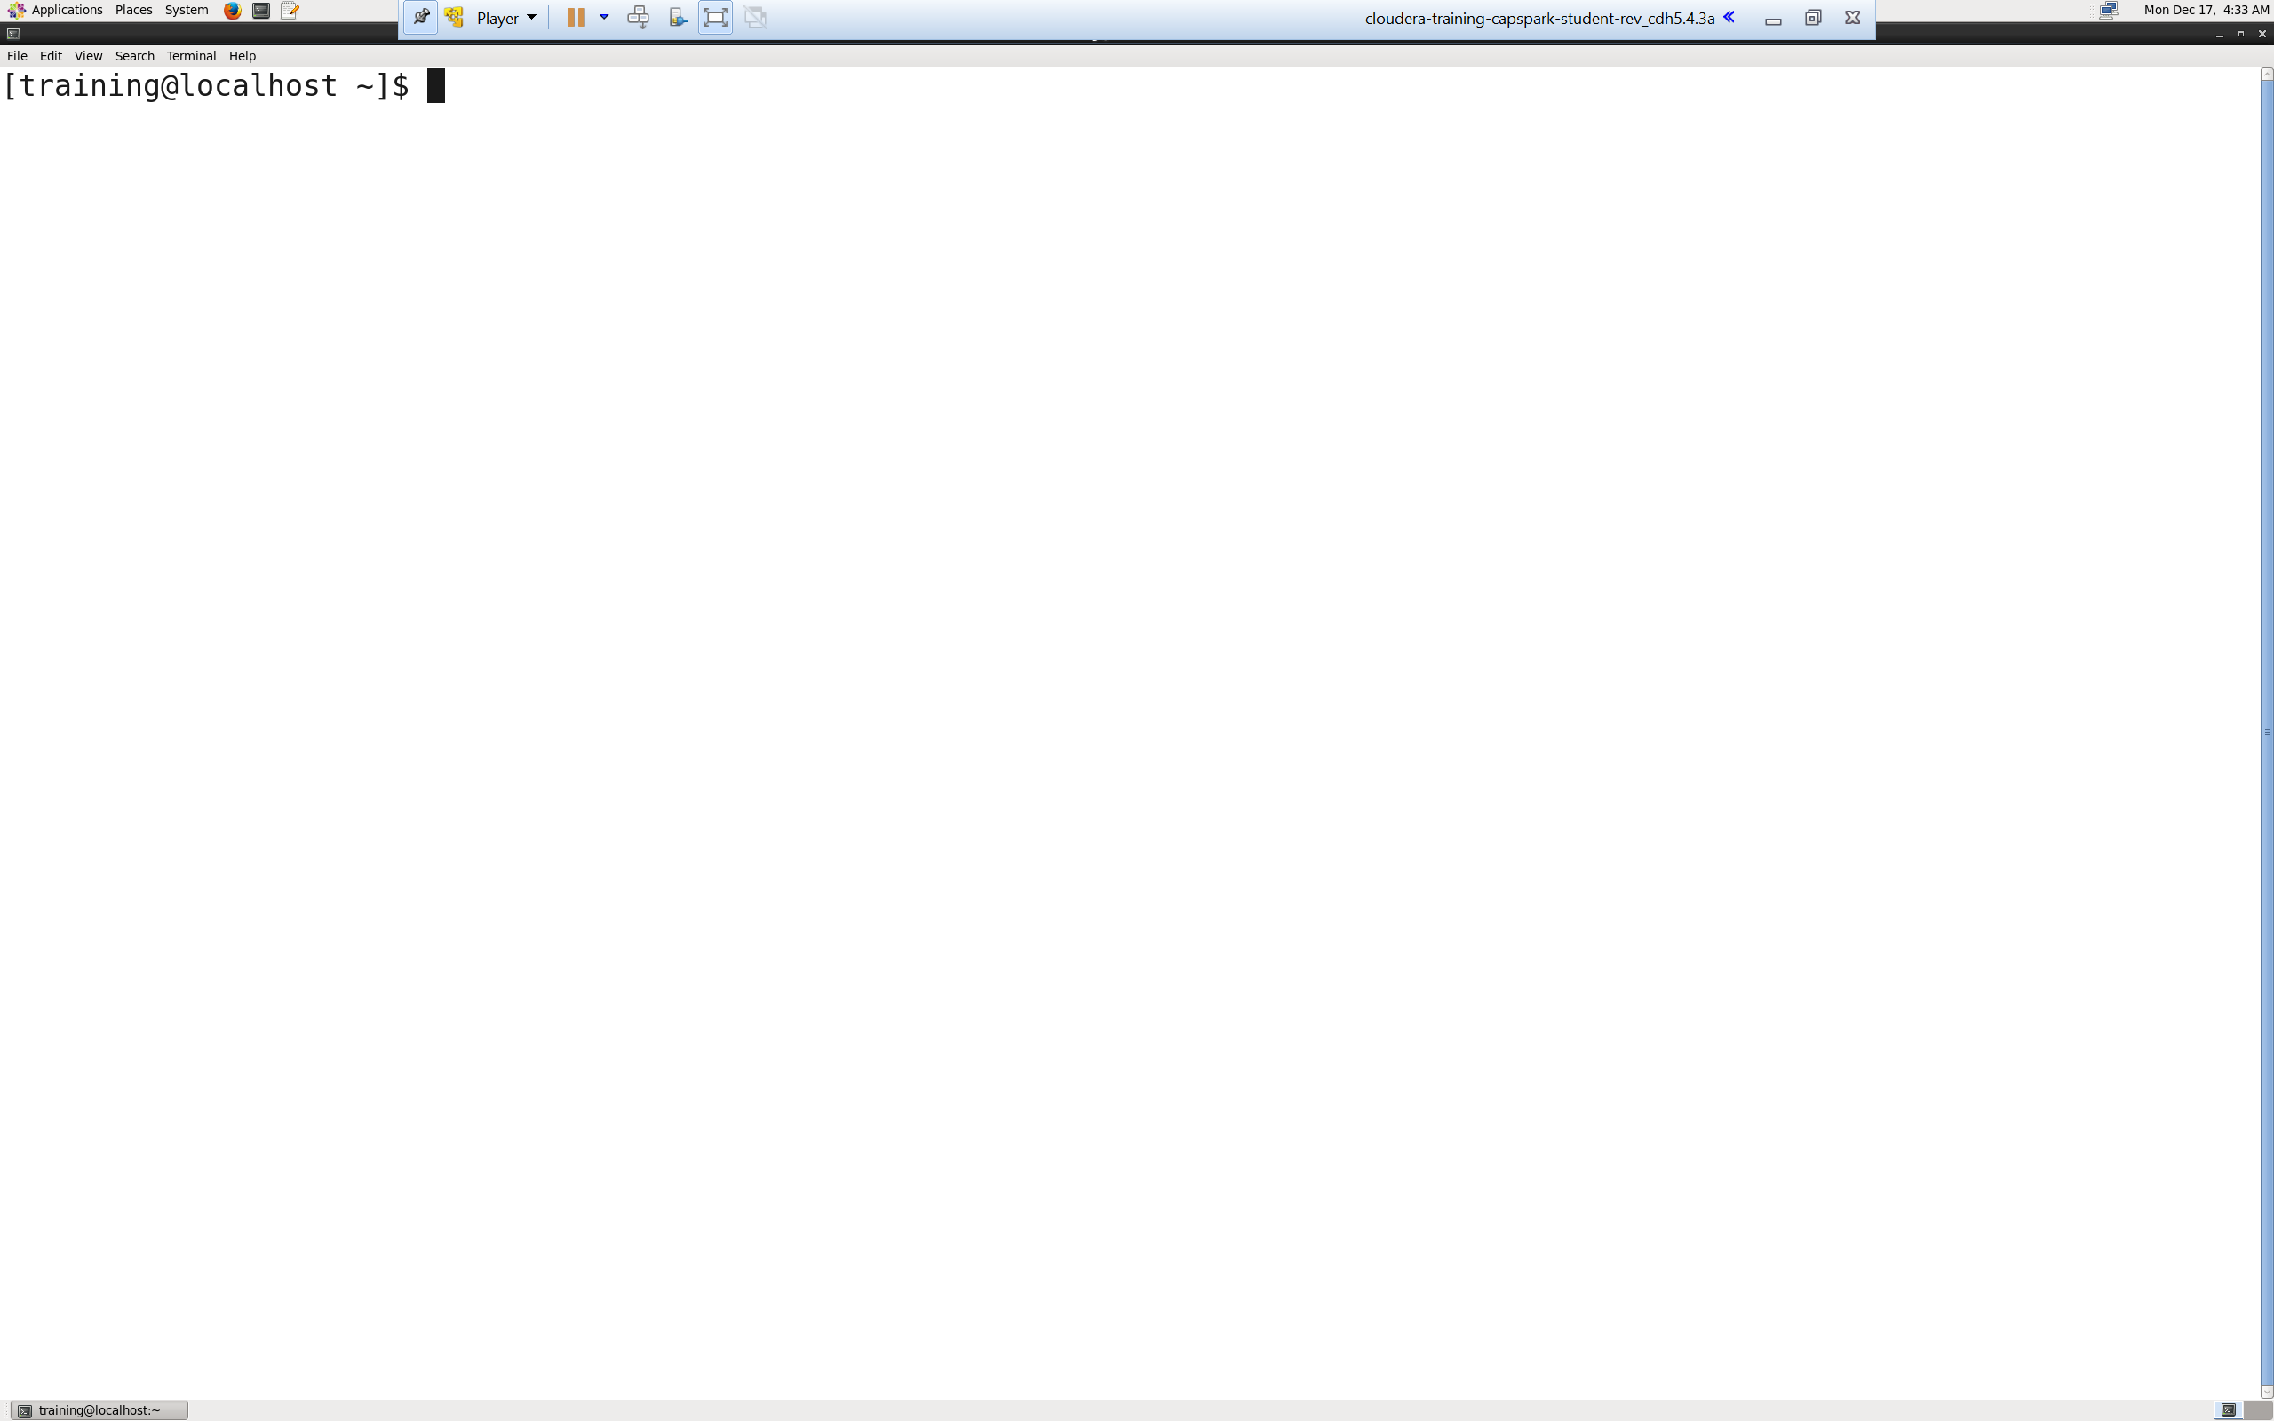Step-1: Start the Cloudera VM and then launch the “terminal” application.

Q. Take a screenshot of the terminal and paste it below.

Step-2: Execute the following command at the shell prompt:

Q. Execute the following command at the shell prompt and take a screenshot of the shell output and paste it below.



Explanation: We are creating a directory in HDFS within the

loudacre_FirstName_LastName directory that we created in Exercise 1. This directory will hold all the data files that we will ingest using Flume.

NOTE:

* Replace FirstName and LastName with your first name and last name, DO NOT copy as is

Step-3: Execute the following command at the shell prompt:

Q. Execute the following command at the shell prompt and take a screenshot of the shell output and paste it below.



Explanation: We are creating a directory on the local system to hold the flume logs that we want to ingest. This directory will serve as the “source” for our flume agent.

NOTE:

* Replace FirstName and LastName with your first name and last name, DO NOT copy as is
* The -p option allows us to create subdirectories as well as the parent directory

Step-4: Execute the following command at the shell prompt:

Q. Execute the following command at the shell prompt and take a screenshot of the shell output, highlight the flume_FirstName_LastName file and paste it below



Explanation: We are assigning all users permission to write to the

flume_FirstName_LastNmae directory.

NOTE:

* Replace FirstName and LastName with your first name and last name, DO NOT copy as is
* chmod is used for assigning/changing permission to a file/directory
* a+w assigns all users (a) permission to write (w) to the file/directory
* -R is used to do this to all subdirectories and files within our flume_FirstName_LastName directory

Part-2: Configuring the Flume Agent: In this section we will create the configuration file for the flume agent.

Step-5: Execute the following command at the shell prompt:



Q. Now type the command and execute. Take a screenshot of the shell output and paste it below.

Explanation: We are changing directories using the “cd” command to the flume directory where we will create our flume configuration file.

Step-6: Execute the following command at the shell prompt:

Enter the following command to enter Insert Mode:



Enter the following text in to the VI editor:

Now, Enter the following commands to save and exit VI editor:



Q. Execute the following command at the shell prompt:

Take a screenshot of the contents of the text file and paste it below.

Explanation:

Lines 1-3: We are aliasing the source, sink and channel for our flume agent.

Lines 5-7: We are configuring the properties for the channel

Line 5: Defining the type of channel (memory)

Line 6: Defining the capacity of the channel (10,000). This means that our channel can store 10,000 events

Line 7: Defining the transaction capacity of the channel (10,000)

Lines 9-11: We are configuring the properties for the source

Line 9: Defining the type of source (spooldir)

Line 10: Defining the location of the source

Line 11: Attaching the channel to this source

Lines 13-19: We are configuring the properties for the sink

Line 13: Defining the type of sink (HDFS)

Line 14: Defining the location of the sink

Line 15: Disabling time-based file rolling

Line 16: Disabling event-based file rolling

Line 17: Enables size-based file rolling

Line 18: Outputs raw text files instead of sequence file format files

Line 19: Attaching the channel to the sink

NOTE:

* Replace FirstName and LastName with your first name and last name, DO NOT copy as is
* The underlined text above refer to the keys on the keyboard
* File rolling specifies when to start a new log file

Part-3: Running Flume: In this section we will cover how to start the flume agent.

Step-7: Execute the following command at the shell prompt:



Q. Take a screenshot of the shell output and paste it below. The flume agent has now started. Why isn’t Flume ingesting any files?

Explanation: This command starts the flume agent.

* The first line of the command specifies the path to additional configuration files that are needed to run the flume agent
* The second and third line of the command specifies the location of the flume configuration file that we created
* The fourth line of the command specifies the name of the flume agent
* The fifth line of the command tells flume to display the log messages in the terminal

NOTE:

* Replace FirstName and LastName with your first name and last name, DO NOT copy as is
* The –name argument must match the name of the flume agent that we specified in the configuration file
* Once the command has been executed the flume agent is active

Part-4: Simulating Web Log Files: This section will cover how to simulate the weblog files that Flume will ingest from the source (spooldir) to the sink (HDFS).

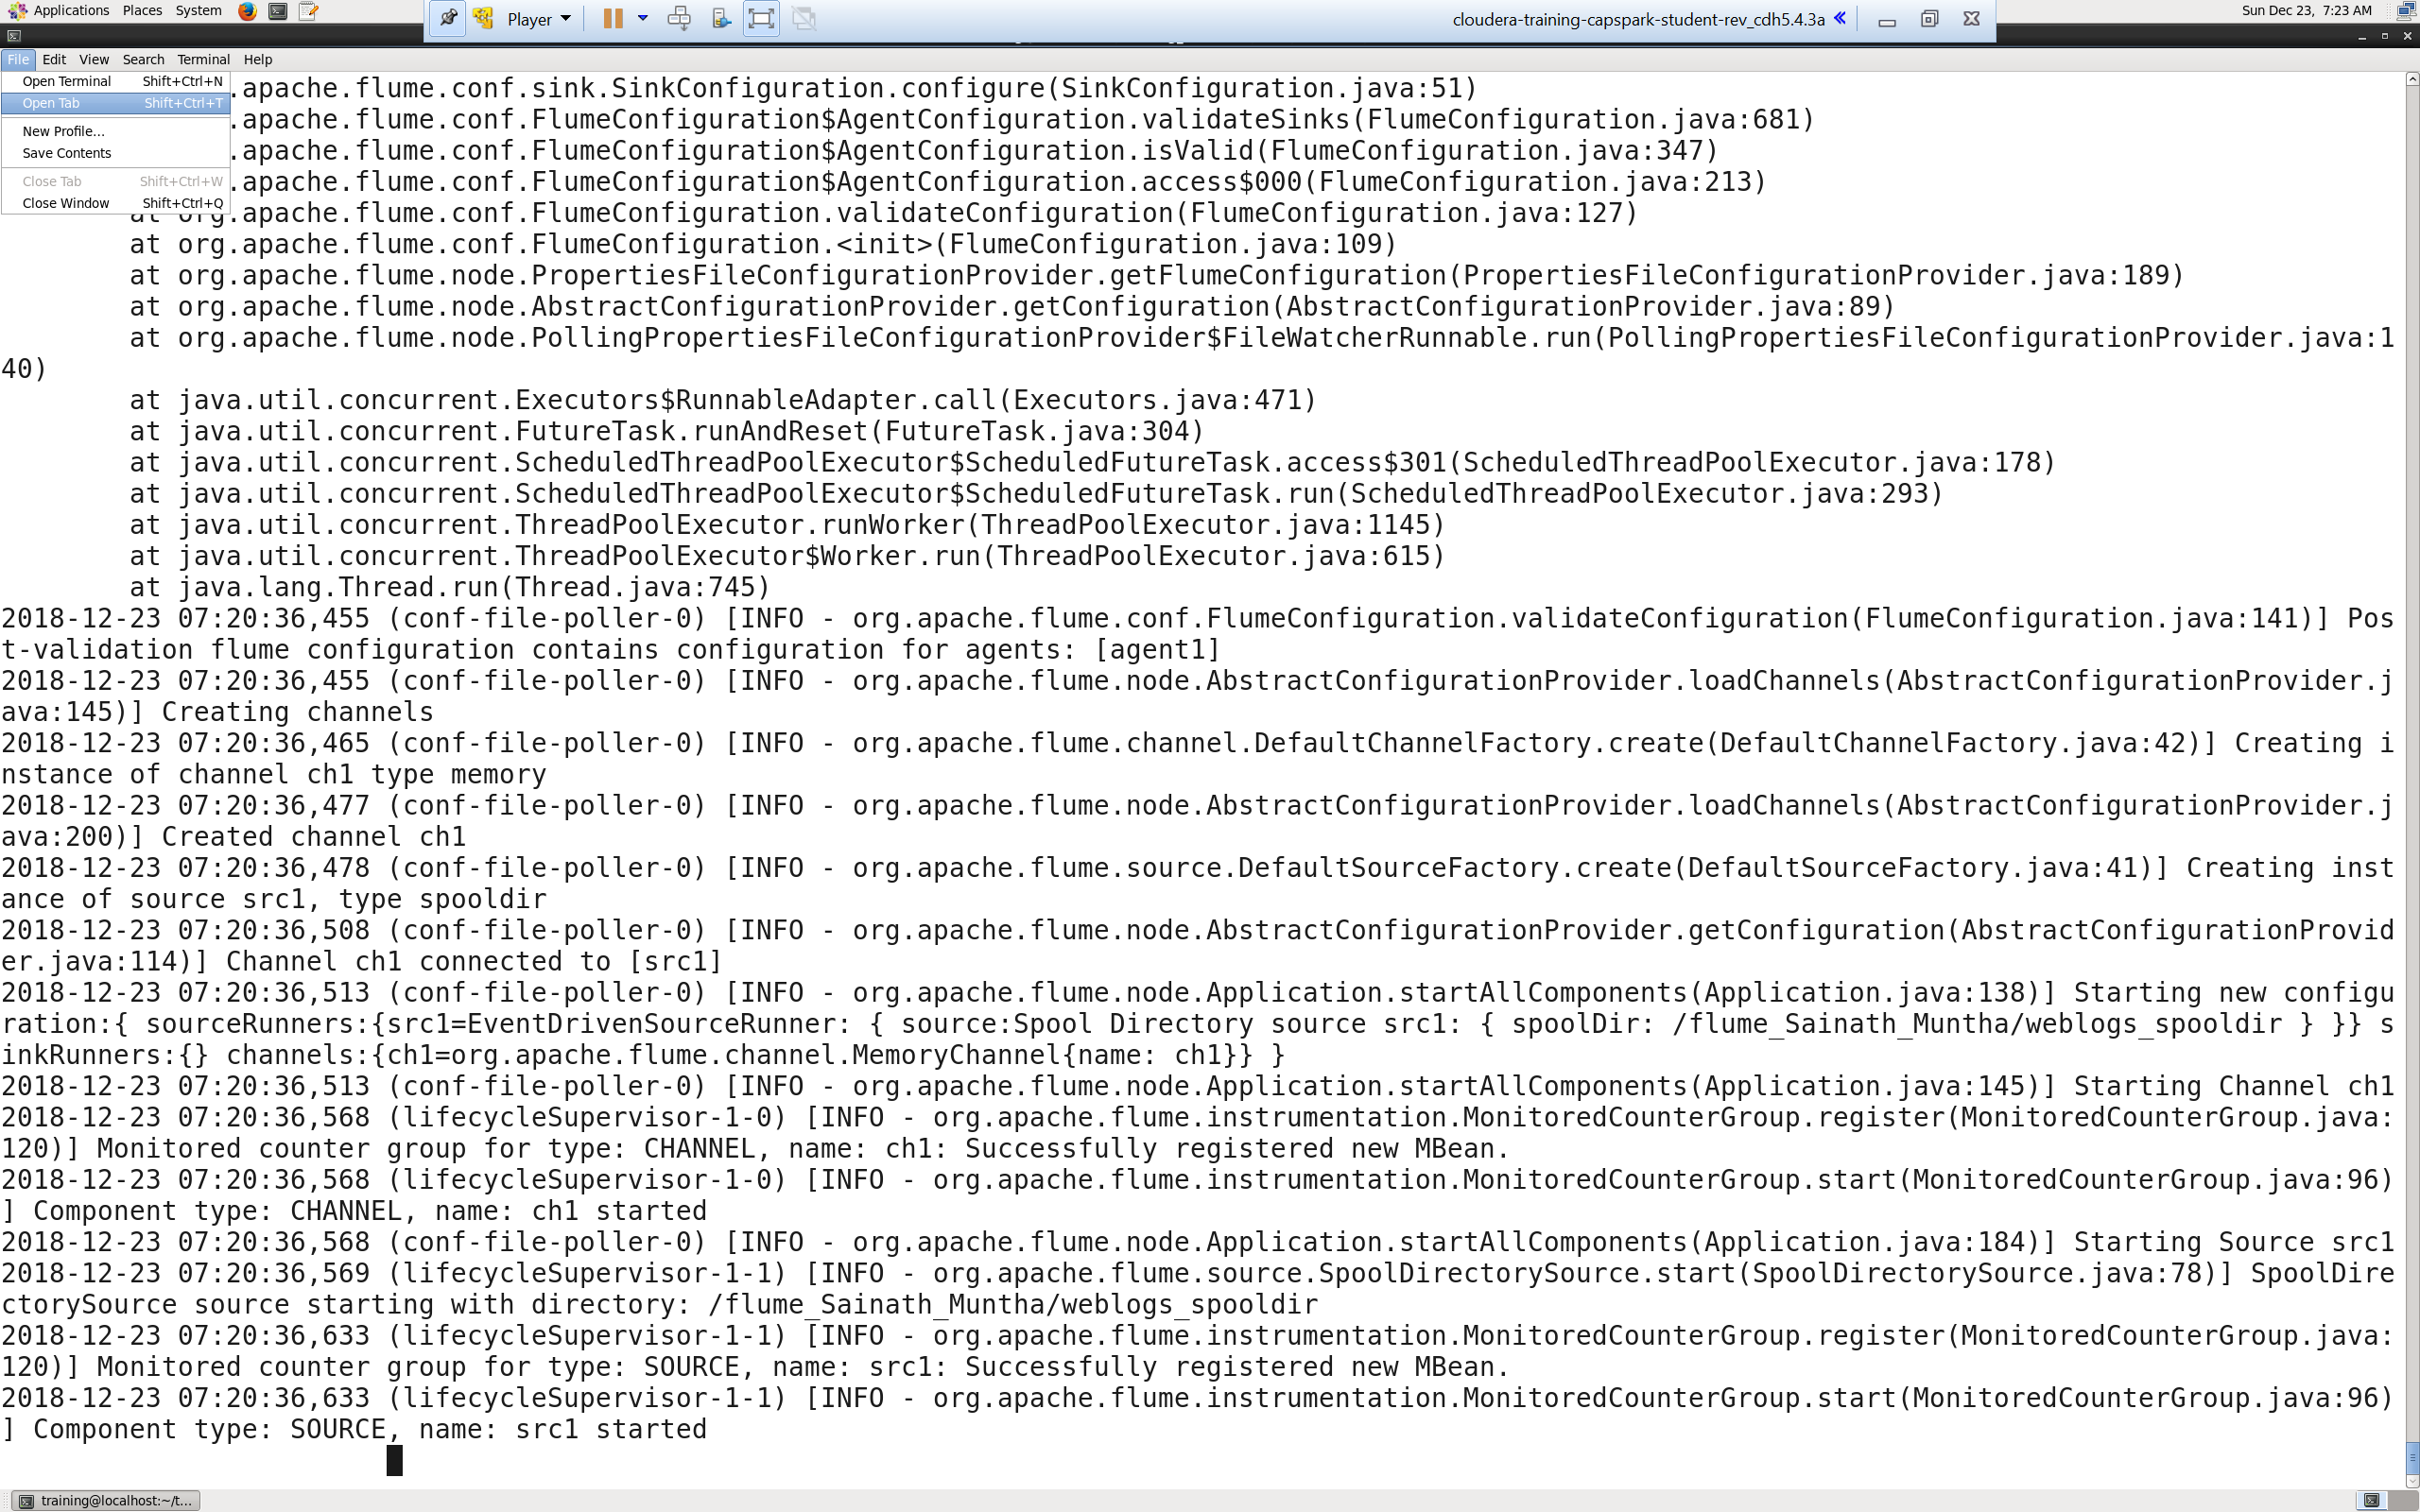Step-8: Open a separate terminal window by clicking on “File” then “Open tab” as shown in the screenshot below. Once you have the second terminal tab open, setup the two terminal windows as shown in the second screenshot below.

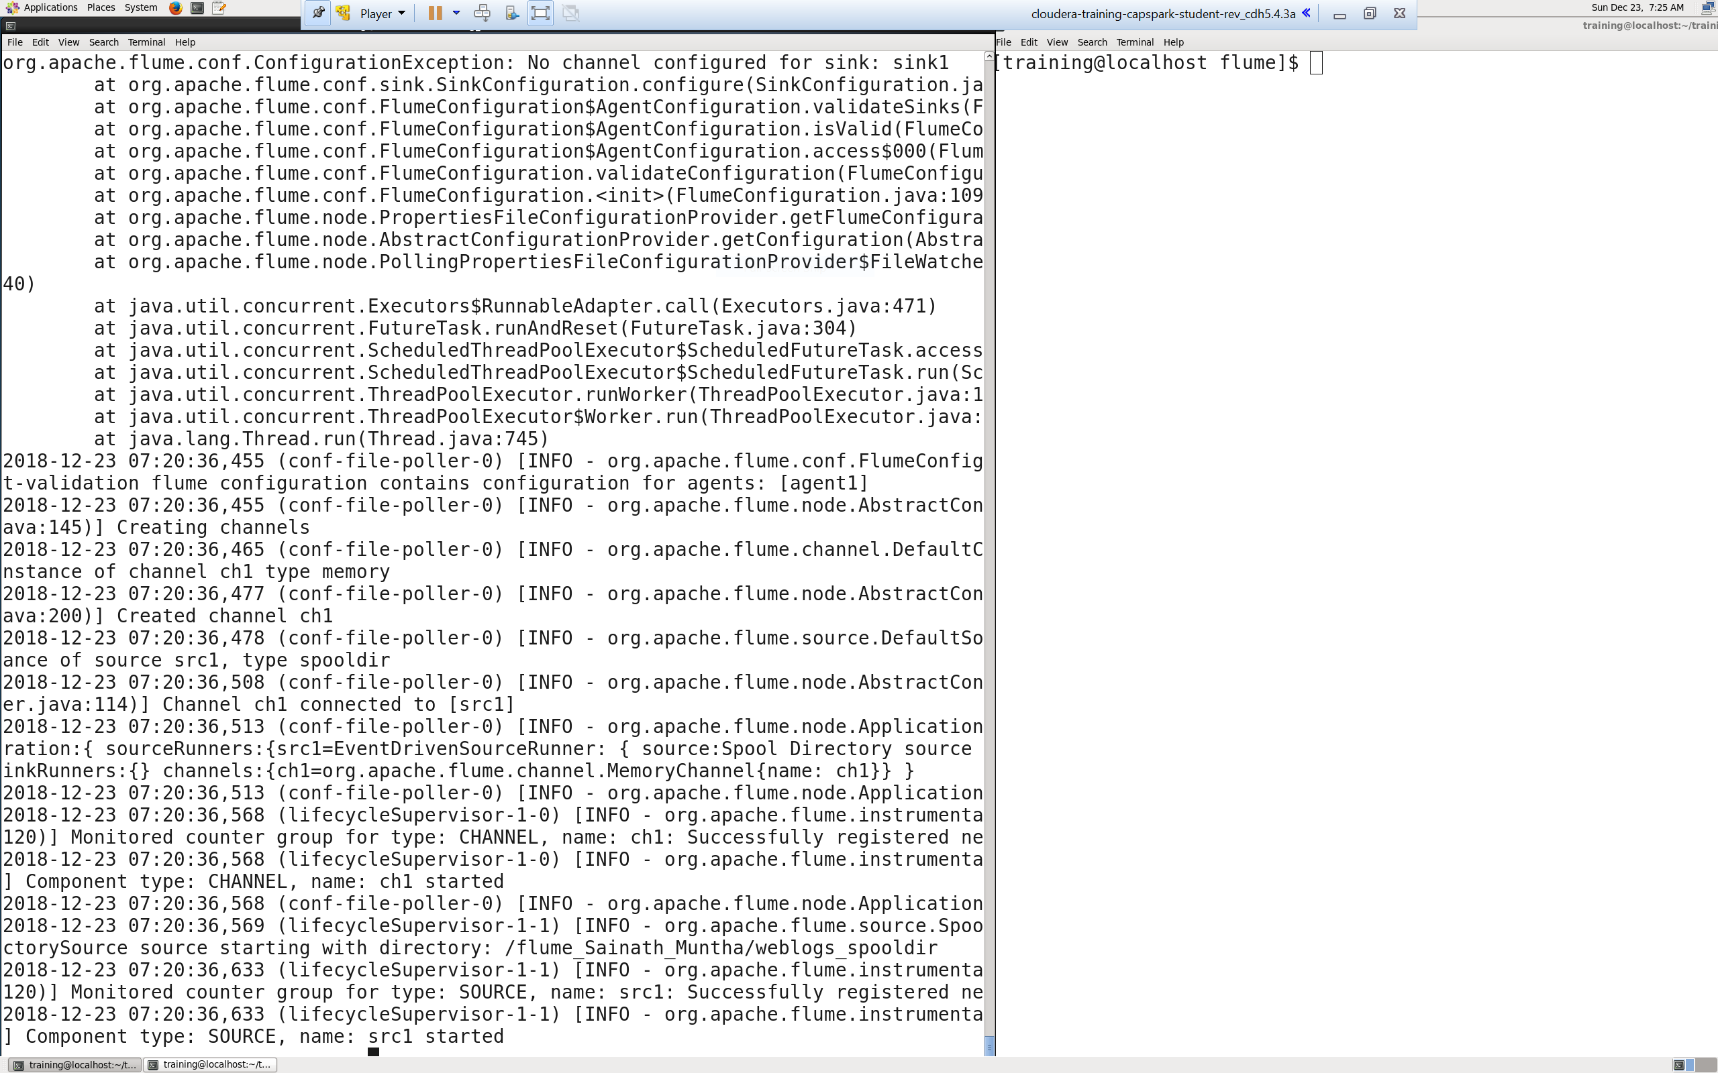

Q. Take a screenshot of the two terminal windows after you have set them up as described.

Step-9: Execute the following command at the shell prompt:

Q. The terminal that is running the flume agent should be displaying the log files that are being ingested. Take a screenshot of these log files while the flume agent is running and paste it below.

Explanation: Prior to this step, the flume agent has started, the source, sink, and channel have been configured but do not have any files to ingest. This step copies weblog files and puts them at our source location, soon as you execute this script, you will see output on the terminal window running your Flume agent.

NOTE:

* Replace FirstName and LastName with your first name and last name, DO NOT copy as is
* This step may take a couple of minutes

Step-10: Once the Flume agent has finished ingesting files, enter the following command in the terminal to terminate Flume:



Q. Using the file browser in HUE, go to the sink location

(/loudacre_FirstName_LastName/weblogs) and take a screenshot of the log files in the weblogs directory and paste it below.

Explanation: We are shutting down the flume agent.

Part-5: Checksum: In this section we will perform a checksum

Step-11: Download the Checksum.zip file from eLearning in to the downloads folder **IN** the Cloudera VM using Mozilla Firefox.

Step-12: Execute the following command:



Q. Now type the command and execute. Take a screenshot of the shell output, highlight the zip file and paste it below.

Step-13: Execute the following command at the shell prompt:



Q. Now type the command and execute. Take a screenshot of the shell output, highlight the contents of the zip file and paste it below.

Explanation: The “unzip” command unzips the zip file.

Step-14: Execute the following command at the shell prompt:

Then execute the following command:

Q. Take a screenshot of the shell output and paste it below.

Step-15: Execute the following command at the shell prompt:

rm Checksum.zip checksum.sh output.txt



Q. Now type the command and execute. Take a screenshot of the shell output and paste it below.

# ADDITIONAL NOTES:

* Make sure to check the spelling before you execute a command, a spelling mistake in one step can snowball and prevent other steps from working.
* Execute means, type in the given command and hit return/enter
* Shell output refers to the output that you see in the terminal application after executing a command
* **SUBMIT A WORD DOCUMENT CONTAINING YOUR SCREENSHOTS IN ELEARNING.**
* **Also submit the Checksum value (32-bit alpha numeric key) from Step-14 in the comments section of the submission as shown in the screenshot below:**

